CSC104-Database Systems  Mid Project Report(Spring 2025) 
Student Details
Repository Name | DBS25P012
Registration Number | 2024-CS-12

Project
Project Title | ITEC Management System
Executive Summary | The ITEC Management System is a comprehensive desktop application designed to streamline various administrative and operational aspects of an ITEC event or organization. At its core, the system is built using Windows Forms in C#, with each module addressing a specific area of management. It interacts with a MySQL database to handle data storage and retrieval, ensuring that all operations—from adding records to updating statuses—are performed efficiently.  One of the key modules is the User Fee Tracking component. This module allows users to view, search, and update fee payment statuses. For example, participants can see details of their event fees, including the event name, fee amount, and whether the fee is pending or has been paid. The interface provides filtering options and search capabilities, making it easy to navigate through a potentially large dataset. Additionally, it includes functionality for marking fees as paid, which updates the database and reflects the change in real time.  The system also includes a Venue Management module, where users can add, update, delete, and search for venue details. This section helps in organizing event locations by capturing essential information such as the venue name, capacity, and location. The intuitive design of the form, complete with a data grid for viewing existing venues, ensures that event organizers can manage venues effectively.  Another important module is Committee Management, which focuses on organizing the committees responsible for various aspects of the event. Here, users can add new committees, update existing ones, and remove committees as necessary. The module ties committee management with the edition of the event (or ITEC edition), ensuring that each committee is aligned with a particular event year or theme. This linkage helps in maintaining consistency and historical data for multiple editions of the event.  In addition to these, the Duty Management module assists in assigning tasks to committee members. It facilitates the scheduling of duties, setting deadlines, and tracking the status of each task. Users can easily update or delete duties, ensuring that the workload distribution remains clear and manageable. The form design incorporates dynamic components like combo boxes that load committee members based on the selected committee, making the process interactive and user-friendly.  Lastly, the Edition Management module allows the system to handle different editions of the ITEC event. By capturing the year, theme, and description for each edition, the system supports historical tracking and planning for future events. Overall, the ITEC Management System is a well-integrated solution that centralizes the management of event fees, venues, committees, duties, and event editions, ultimately enhancing the operational efficiency and organization of the event.

Login Page
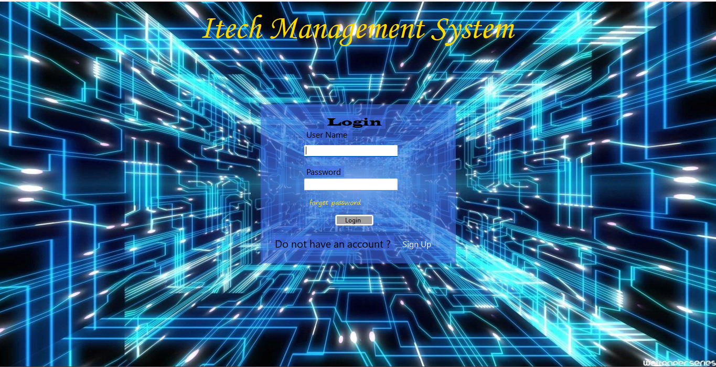

UI Component Name  Login Page | Type of UI component | Class Name and Attributes  Login.cs  LoginBL  LoginDL  UserID  UserName  RoleID  RoleName  PasswordHash | Linked to which database column/table  users  roles  lookup
In case of column, write column name and in case of multiple columns, write query in last column

Sign UP page
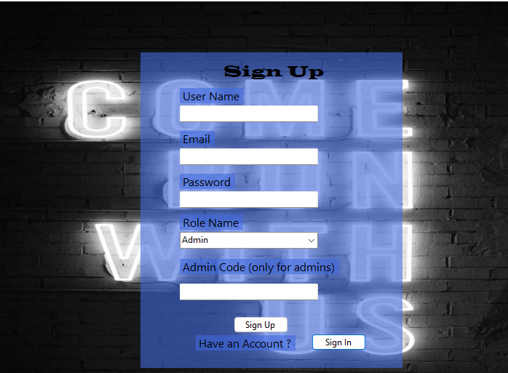

UI Component Name  Sign Up page | Type of UI component | Class Attribute name,  SignUp.cs  SignUpBL  SignUpDL  UserID  UserName  Email  PasswordHash  RoleID  RoleName | Linked to which database column/table  users  roles  lookup
In case of column, write column name and in case of multiple columns, write query in last column

ITEC Edition Management
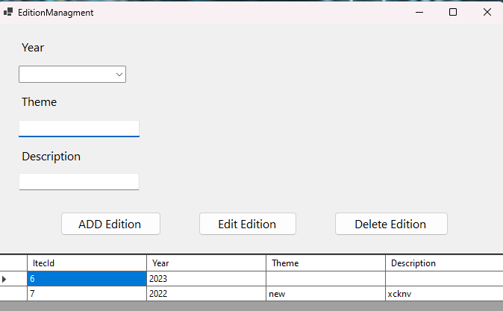
UI Component Name  Edition Management | Type of UI component | Class Attribute name,  Edition.cs  EditionBL  EditionDL  ItecID  Year  theme | Linked to which database column/table  itec_editions
In case of column, write column name and in case of multiple columns, write query in last column

Event Management
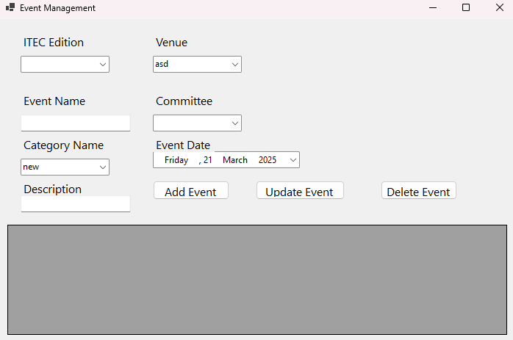

UI Component Name  Event Management | Type of UI component | Class Attribute name,  Event.cs  EventBL  EventDL  EventID  EventNAme  ItecID  EventCategoryID  Description  EventDate  VenueID  CommitteeID | Linked to which database column/table  events  itec_editions  event_categories  venues  commitees  lookup
In case of column, write column name and in case of multiple columns, write query in last column
Participant Registration
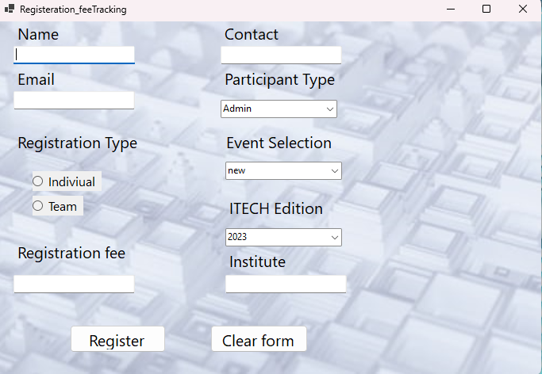

UI Component Name  Participant registration | Type of UI component | Class Attribute name,  Participant.cs  ParticipantBL  ParticipantDL  RegistrationID  ParticipantName  EventName  FeeAmount  PaymentStatusID  PaymentStatus | Linked to which database column/table  participants  event_participants  lookup
In case of column, write column name and in case of multiple columns, write query in last column

Committee Management
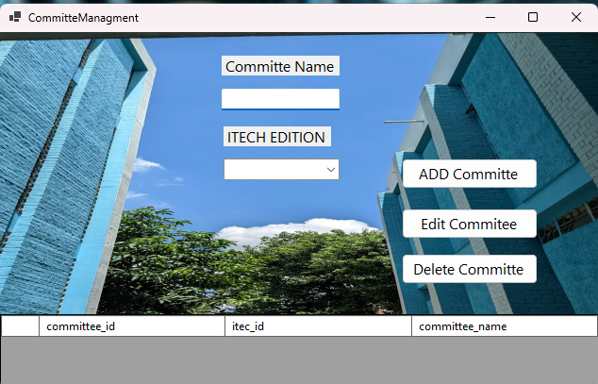

UI Component Name  Committee Management | Type of UI component | Class Attribute name,  Committee.cs  CommitteeBL  CommitteDL  CommiteeID  CommitteeName  ItecID | Linked to which database column/table  committees  itec_editions
In case of column, write column name and in case of multiple columns, write query in last column
Duty Management
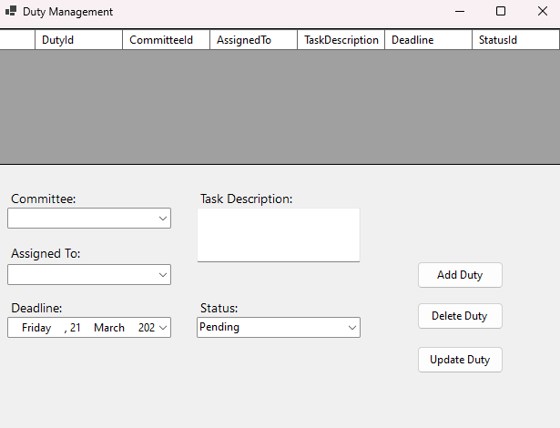

UI Component Name  Duty Management | Type of UI component | Class Attribute name,  Duty.cs  DutyBL  DutyDL  DutyId  AssignedTo  CommitteID  TaskDescription  Deadline  StatusID | Linked to which database column/table  duties  lookup  committees
In case of column, write column name and in case of multiple columns, write query in last column

Finance Management
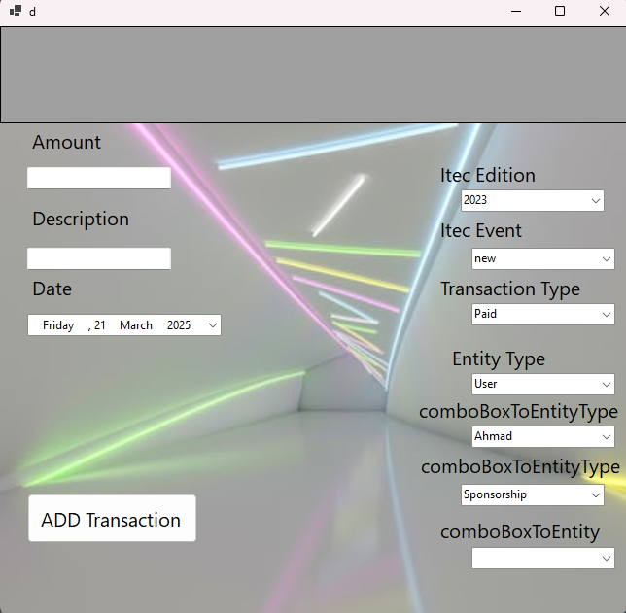

UI Component Name  Financial Management | Type of UI component | Class Attribute name,  FinancialManagement.cs  FinanceBL  FinanceDL  TransactionID  ItecID  EventID  Amount  FromEntityType  ToEntityType  Description  DateRecorded | Linked to which database column/table  itec_editions  events  finances  lookup
In case of column, write column name and in case of multiple columns, write query in last column

Venue Allocation

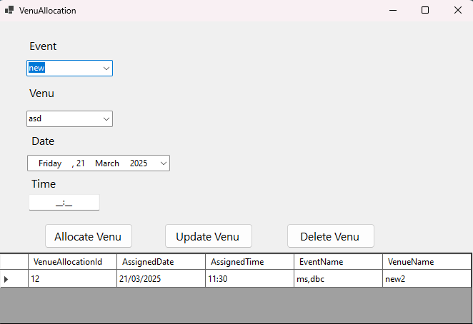

UI Component Name  Venue Allocation | Type of UI component | Class Attribute name,  Venue.cs  VenueBL  VenueDL  VenueID  VenueName  EventID | Linked to which database column/table  venues  venue_allocations
In case of column, write column name and in case of multiple columns, write query in last column

Venue Management
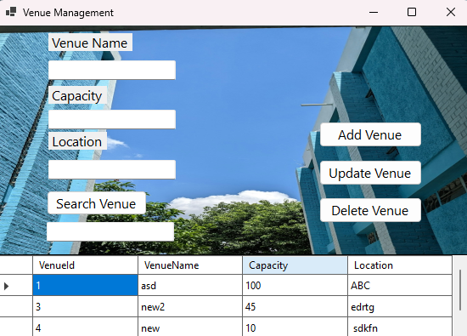

UI Component Name  Venue Management | Type of UI component | Class Attribute name,  VenueManagement.cs  VenueBL  VenueDL  VenueID  VenueName  Capacity  Location | Linked to which database column/table  venues
In case of column, write column name and in case of multiple columns, write query in last column
Event Result Management
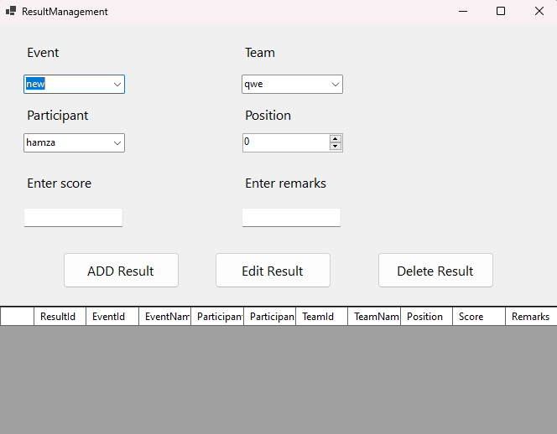

UI Component Name  Event Result Management | Type of UI component | Class Attribute name,  EventResultManagement.cs  ResultBL  ResultDL  ResultID  EventID  EventName  ParticipantID  Participantname  TeamID  TeamName  Position  Score  Remarks | Linked to which database column/table  event_results  participants  itec_events  teams
In case of column, write column name and in case of multiple columns, write query in last column

Members Management
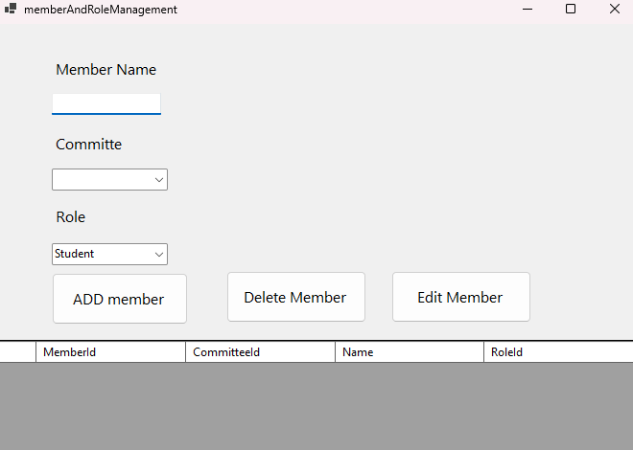
UI Component Name  Members Management | Type of UI component | Class Attribute name,  memberManagement.cs  mmemberBL  memberDL  MemberID  RoleID  CommiteeID  Name | Linked to which database column/table  commitees  committee_members
In case of column, write column name and in case of multiple columns, write query in last column
Fee Tracking
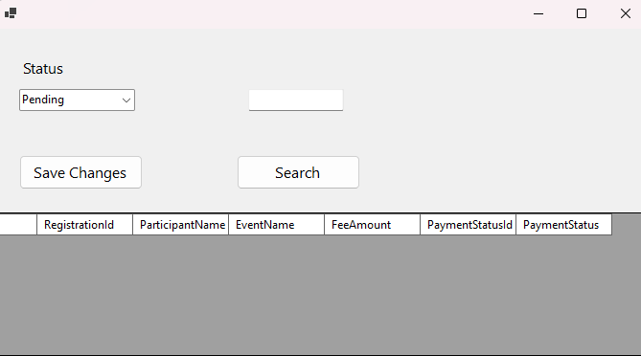

UI Component Name  Fee tracking | Type of UI component | Class Attribute name,  Feetracking.cs  PaymentTrackingBL  PaymentTrackingDL  RegistrationID  ParticipantName  EventName  FeeAmount  PaymentStatus  PaymentStatusId | Linked to which database column/table  participants  event_participants  itec_events
In case of column, write column name and in case of multiple columns, write query in last column

Sponsor Management
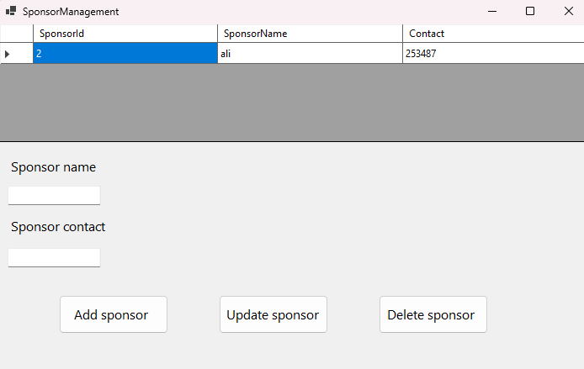

UI Component Name  Sponsors Management | Type of UI component | Class Attribute name,  SponsorManagement.cs  SponsorBL  SponsorDL  SponsorID  SponsorName  Contact | Linked to which database column/table  sponsors
In case of column, write column name and in case of multiple columns, write query in last column

Vendor Management
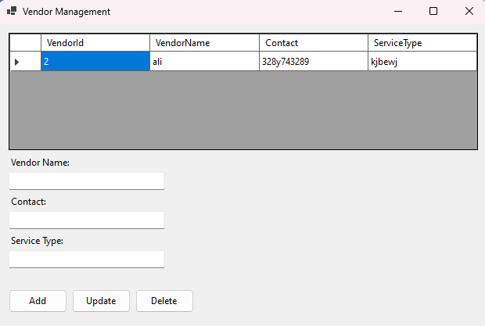

UI Component Name  Vendors Management | Type of UI component | Class Attribute name,  VendorManagement.cs  VendorBL  VendorDL  VendorId  VendorName  Contact  ServiceType | Linked to which database column/table  vendors
In case of column, write column name and in case of multiple columns, write query in last column

TeamRegistrationForm
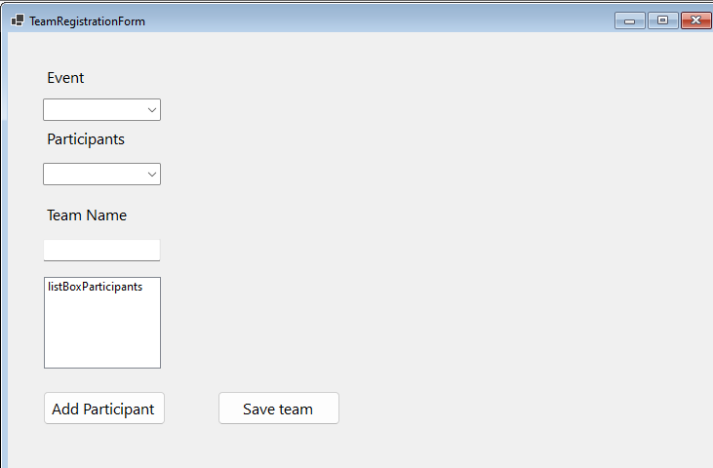
UI Component Name  Team Registration | Type of UI component | Class Attribute name,  Team.cs  TeamBL  TeamDL  TeamID  TeamName  EventId | Linked to which database column/table  teams  teams_participant
In case of column, write column name and in case of multiple columns, write query in last column

Business Report-1
Business Report Name:
Sample of report:
Query to build Report:

Business Report-2
Business Report Name:
Sample of report:
Query to build Report:

